INTERNATIONAL HISTOLOGY OLYMPIAD GUIDELINE
AIM AND OBJECTIVES
1. Promote Interest in Histology:
- Spark curiosity and interest in the study of cells, tissues, and organs among students.
- Showcase the beauty and complexity of biological structures at the microscopic level.
- Inspire participants to appreciate the importance of histology in understanding health, disease, and biological processes.
2. Foster Scientific Knowledge:
- Provide a platform for participants to deepen their understanding of histological concepts, techniques, and applications.
- Encourage participants to engage in research, experimentation, and critical thinking in the field of histology.
- Facilitate knowledge sharing and collaboration among participants from different backgrounds and regions.
3. Build International Cooperation:
- Foster cross-cultural understanding and collaboration among participants from different countries and regions.
- Create networking opportunities for histology enthusiasts to connect, share ideas, and build professional relationships.
- Strengthen international ties in the field of histology and promote global awareness of advancements in the discipline.
ELIGIBILITY
- Undergraduate medical students, who has histology knowledge are eligible and contestants will participate independently.
- This competition is open to students from different countries and regions around the world to promote diversity and global collaboration
- English fluency is required. Competition will be held in English
OLYMPIAD STRUCTURE
The Olympiad will be held in 3 rounds. Preliminary round selection will be done through test, second round selection will be done through the ability to identify specific histological structures on human organ system preparations. Final round will evaluate the ability to correlate histological structures with clinical case.
TIMEFRAME
Registration: April 11, 2024, 2024 -May 19, 2024
First round: May 20, 2024
Second round: June 24, 2024
Award ceremonies: June 24, 2024
TOPICS
Competition will cover the issues regarding the theoretical and practical aspect of cell biology, tissue and organ structure.
JUDGING CRITERIA
- Participants will be evaluated based on accuracy, speed and creativity.
- Judges will be selected from the participating university and histology subject lecturers are eligible.
PRIZES AND AWARDS
-1st places-500$
-2nd places 2-person-300$
-3rd places 3-person-200$
REGISTRATION PROCESS
- Registration will proceed from April 11 till May 19, 2024.
- International participants can register using following QR code.
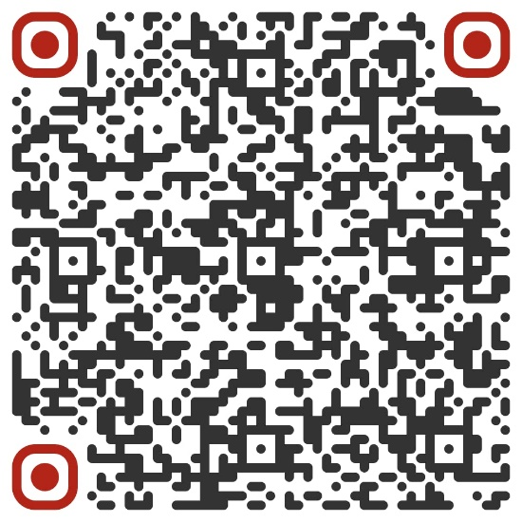
EVENT VENUE
- First and second round of competition will hold by using online platform.
- Third round of competition will be held in MNUMS, UB, Mongolia

